

**CAPSTONE PROJECT REPORT**

**Report 3 – Software Requirement Specification**

– HoChiMinh, September 2020 –

**Table of Contents**

I. Project Report 3

1. Status Report 3

2. Team Involvements 3

3. Issues/Suggestions 3

II. Software Requirement Specification 4

1. Overall Description 4

1.1 Product Overview 4

1.2 Business Rules 4

2. User Requirements 5

2.1 Overview 5

2.2 List of use case 6

2.3 <<Feature name 2 – i.e: Meal Subscriptions>> 47

2.4 <<Next Feature Name..>> 47

3. Functional Requirements 48

3.1 System Functional Overview 48

3.2 <<Feature Name 1>> 50

3.3 <<Feature Name 2>> 50

4. Non-Functional Requirements 51

4.1 External Interfaces 51

4.2 Quality Attributes 52

5. Other Requirements 54

5.1 Appendix1 - Messages List 54

5.2 Appendix2 - … 54

5.3 … 54

# I. Project Report

## 1. Status Report

|  |  |  |  |
| --- | --- | --- | --- |
| **#** | **Work Item** | **Status** | **Notes (Work Item in Details)** |
| 1 |  | Pending |  |
| 2 |  | In Progress |  |
| 3 |  | Completed |  |

## 2. Team Involvements

|  |  |  |  |
| --- | --- | --- | --- |
| **#** | **Task** | **Member** | **Notes (Task Details, etc.)** |
| 1 |  | Thaott |  |
| 2 |  | Datbc |  |
| 3 |  | Kiendst |  |
| 4 |  | Mytn |  |

## 3. Issues/Suggestions

|  |  |  |  |
| --- | --- | --- | --- |
| **#** | **Issue** | **Status** | **Notes (Solution, Suggestion, etc.)** |
| 1 |  | Pending |  |
| 2 |  | In Progress |  |
| 3 |  | Completed |  |

# II. Software Requirement Specification

## 1. Overall Description

### 1.1 Product Overview

Hệ thống đặt thợ chụp ảnh là một hệ thống mới hỗ trợ khách hàng tìm kiếm nhanh chóng thợ chụp ảnh. Sơ đồ ngữ cảnh bên dưới mô tả các thực thể bên ngoài và giao diện của hệ thống phiên bản 1.0. Hệ thống sẽ dự kiến phát triển trong khu vực thành phố kết nối với các thợ chụp ảnh và studio.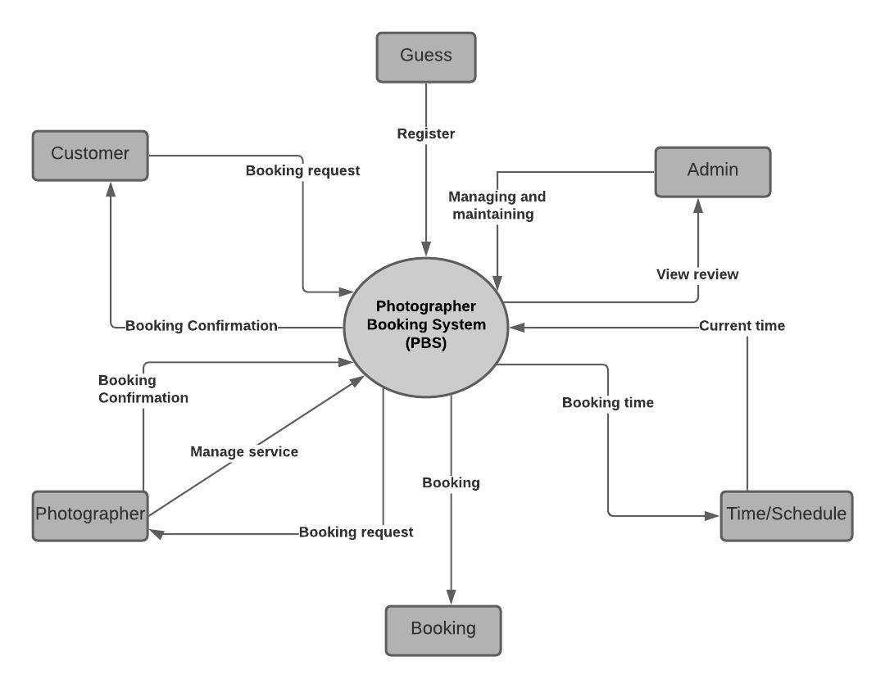

***Figure 1 - Context Diagram***

### 1.2 Business Rules

|  |  |
| --- | --- |
| **ID** | **Rule Definition** |
| BR-01 | Thợ chụp ảnh phải cập nhật trạng thái yêu cầu của khách hàng trong 24h. |
| BR-02 | Khách hàng chỉ được đặt thợ trước trong vòng 3 tháng trở lại. |
| BR-03 | Khách hàng đã đánh giá thì không có quyền xóa bình luận đó. |
| BR-04 | Sau khi đặt lịch khách hàng có quyền sửa đổi thông tin trước khi thợ chụp ảnh xác nhận. |
| BR-05 | Khách hàng được phép hủy yêu cầu trong khi trạng thái là: “Chờ xác nhận” và “Sắp diễn ra”. |
| BR-06 | Khách hàng nếu hủy yêu cầu từ trạng thái “sắp diễn ra” phải nêu lý do và chờ photographer xác nhận |
| BR-07 | Thời gian nhận khách hàng không thể chọn ngày trong quá khứ. |
| BR-08 | Thợ chụp ảnh không được phép xóa bình luận của khách hàng. |
| BR-09 | The admin locks users when they violate business rules. |
| BR-10 | Quản trị viên không được phép viết bình luận và bình chọn sao cho photographer. |
| BR-11 | Quản trị viên không được phép xóa bình luận của photographer |
| BR-12 | Only the admin can add a shooting category. |
| BR-13 | Only the admin can edit the shooting category. |
| BR-14 | Only the admin can remove the shooting category. |
| BR-15 | Sau khi đã đặt lịch chụp ảnh thì người khác không thể đặt lịch vào giờ đó. |
| BR-16 | Khách hàng nếu muốn hủy yêu cầu trong trạng thái “Sắp diễn ra” thì phải hủy trước 24 giờ. |

***Table 1 - Business rules***

## 2. User Requirements

### 2.1 Overview

#### a. Use Case Diagram

***Figure 2 - Use Case Diagram***

#### b. System Actors

|  |  |  |
| --- | --- | --- |
| **#** | **Actor** | **Description** |
| 1 | Administrator | Là người sẽ quản lý toàn hệ thống. |
| 2 | Photographer | Là người sẽ nhận được yêu cầu của khách hàng và sẽ nhận được đánh giá của khách hàng. Thợ chụp ảnh sẽ xác nhận yêu cầu được gửi đến, thông báo khi đến ngày chụp, ngày trả ảnh. Họ sẽ cung cấp các dịch vụ , hình ảnh cho hệ thống. |
| 3 | Customer | Là người sẽ tìm kiếm thợ chụp ảnh và gửi yêu cầu đến cho thợ. Sẽ nhận được thông báo khi photographer xác nhận yêu cầu, đến ngày chụp, ngày trả ảnh.. Họ sẽ đánh giá chất lượng của thợ chụp ảnh sau khi hoàn thành yêu cầu. |
| 4 | Guest | Là người sẽ đăng kí tài khoản vào hệ thống và sẽ nhận được phản hồi từ hệ thống. |

***Table 2 - System Actors***

#### c. Use Cases List

|  |  |  |  |
| --- | --- | --- | --- |
| **ID** | **Use Case** | **Primary Actors** | **Secondary Actors** |
| 01 | Register | Guest |  |
| 02 | Login | Guest |  |
| 03 | Search photographer | Customer |  |
| 04 | Get photographer’s detail | Customer |  |
| 05 | Book Photographer | Customer |  |
| 06 | Review photographer | Customer |  |
| 07 | Get booking  (cancel, edit, accept, decline) | Customer, Photographer |  |
| 08 | Edit working calendar | Photographer |  |
| 09 | Get customer’s review | Photographer , Admin |  |
| 10 | Manage service  (Add , Edit, Remove) | Photographer |  |
| 11 | Manage album  (add , edit, remove) | Photographer |  |
| 12 | Manage user  (get user’s activity, unlock user, lock user) | Admin |  |
| 13 | Manage shooting category  (add, edit, remove) | Admin |  |
| 14 | Get profile  (edit profile) | Authenticated User |  |
| 15 | Logout | Authenticated User |  |
| 16 | Change password | Authenticated User |  |

***Table 3 - Use Case List***

### 2.2 List of use case

#### a. <Guest > Overview use case

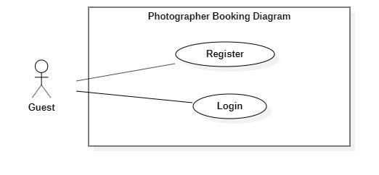

***Figure 3 - <Guest> Overview Use Case***

1. ***<Guest> Register***

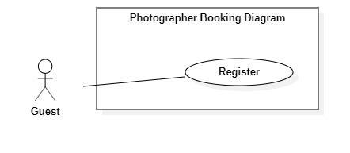

***Figure 4 - <Guest> Register***

|  |  |  |  |
| --- | --- | --- | --- |
| UC ID and Name: | **PBS-UC-01 Register** | | |
| Created By: | Truong Ngoc My | Date Created: | 08/10/2020 |
| Primary Actor: | Guest | Secondary Actors: |  |
| Trigger: | The Guest taps “Đăng ký” on “Đăng nhập” screen | | |
| Description: | The guest wants to register an account. | | |
| Preconditions: | - Guests launch mobile applications.  - Guest is at the “Đăng nhập” screen.  - Guests have connected to the Internet. | | |
| Post-conditions: | Success: The guest registers an account as a customer or photographer. | | |
| Normal Flow: | |  |  |  | | --- | --- | --- | | **Step** | **Actor Action** | **System Response** | | 1 | The Guest taps “Đăng kí” on “Đăng nhập” screen. | The system shows a “Thông tin đăng ký” screen with the following inputs.  -“Họ và tên”: text input, required.  - “ Tên đăng nhập”: text input, required  - “Mật khẩu” : password input , required.  -“Xác nhận mật khẩu”: password input , required.  -“Số điện thoại”: phone number input.  - “Email”: text input, required. | | 2 | The guest taps the “Đăng kí” button. | - The system validates inputted data [Exception 1,2,3,4,5,6].  - The system shows the “Đăng nhập” screen. | | | |
| Alternative Flows: | N/A | | |
| Exceptions: | |  |  |  | | --- | --- | --- | | **No** | **Actor Action** | **System Response** | | 1 | - “Họ và tên” is empty  - “Tên đăng nhập” is empty  - “Mật khẩu” is empty  - “Xác nhận mật khẩu” is empty.  - “Số điện thoại” is empty  - “Email” is empty | System shows an error message: “Thông tin này là bắt buộc” | | 2 | Password and Confirm password is not matched. | System shows an error message: “Mật khẩu nhập lại không khớp”. | | 3 | Register successfully | System shows an error message: “Đăng ký thành công”. | | 4 | “Email” Is invalid | System shows an error message:  “Email mail này không hợp lệ. Vui lòng nhập email khác.” | | 5 | - “Tên đăng nhập” not enough character.  - “Mật khẩu” not enough character. | System shows an error message:  “Bạn vui lòng nhập đủ 8 – 16 kí tự.” | | 6 | “Tên đăng nhập” is exist. | System shows an error message:  “Tên đăng nhập của bạn đã có người sử dụng. Vui lòng nhập tên khác.” | | | |
| Priority: | Medium | | |
| Frequency of Use: | Always | | |
| Business Rules: |  | | |
| Other Information: | N/A | | |
| Assumptions: |  | | |

***Table 4 - <Guest> Register use case specification***

1. ***<Guest> Login***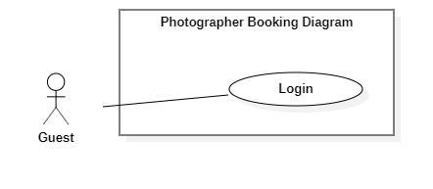

***Figure 5 - <Guest> Login***

|  |  |  |  |
| --- | --- | --- | --- |
| UC ID and Name: | **PBS-UC-02 Login** | | |
| Created By: | Truong Ngoc My | Date Created: | 08/10/2020 |
| Primary Actor: | Guest | Secondary Actors: |  |
| Trigger: | The Guest taps “Đăng nhập” on “Đăng nhập” screen | | |
| Description: | The guest wants to login to the system. | | |
| Preconditions: | - Guests launch mobile applications.  - Guest is at the “Đăng nhập” screen.  - Guests have connected to the Internet. | | |
| Post-conditions: | Success: The guest login to the system as a role customer or photographer. | | |
| Normal Flow: | |  |  |  | | --- | --- | --- | | **Step** | **Actor Action** | **System Response** | | 1 | The Guest opened a mobile app. | “Đăng nhập” screen is show with the following inputs:  - “ Tên đăng nhập”: text input, required  - “Mật khẩu” : password input , required.  - “Đăng nhập” : button | | 2 | The guest inputs the name and password and taps the “Đăng nhập” button. | - The system validates inputted data [Exception 1,2]  - The system shows the main screen. | | | |
| Alternative Flows: | N/A | | |
| Exceptions: | |  |  |  | | --- | --- | --- | | **No** | **Actor Action** | **System Response** | | 1 | - “Tên đăng nhập” is empty  - “Mật khẩu” is empty | System shows an error message : “Thông tin này là bắt buộc” | | 2 | Name and Password is incorrect. | System shows an error message : “Thông tin đăng nhập không chính xác”. | | | |
| Priority: | Medium | | |
| Frequency of Use: | Always | | |
| Business Rules: |  | | |
| Other Information: | N/A | | |
| Assumptions: |  | | |

***Table 5 - <Guest> Login use case specification***

#### b. <Customer> Overview use case

***Figure 6 - <Customer> Overview use case***

1. ***<Customer> Search Photographer***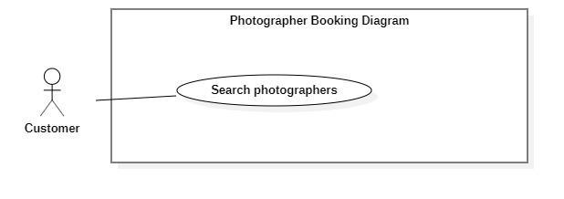

***Figure 7 - <Customer> Search Photographer***

|  |  |  |  |
| --- | --- | --- | --- |
| UC ID and Name: | **PBS-UC-03 Search photographer** | | |
| Created By: | Truong Ngoc My | Date Created: | 08/10/2020 |
| Primary Actor: | Customer | Secondary Actors: |  |
| Trigger: | The customer sends request to find photographers | | |
| Description: | The customer needs to find photographers. | | |
| Preconditions: | - The customer has been authenticated.  - The customer has accessed the Internet. | | |
| Post-conditions: | Success: A list of photographers is shown.  Fail: System shows error messages. | | |
| Normal Flow: | |  |  |  | | --- | --- | --- | | **Step** | **Actor Action** | **System Response** | | 1 | The customer input name photographer or service name after clicking the search icon button. | - The system validates inputted data.  - The system shows a list photographer or service name. | | | |
| Alternative Flows: | N/A | | |
| Exceptions: | N/A | | |
| Priority: | Medium | | |
| Frequency of Use: | Sometimes | | |
| Business Rules: | N/A | | |
| Other Information: | The customer can view a list of available photographers and categories of the main screen. | | |
| Assumptions: |  | | |

***Table 6 - <Customer> Search photographer use case specification***

1. ***<Customer> Get photographer’s detail***

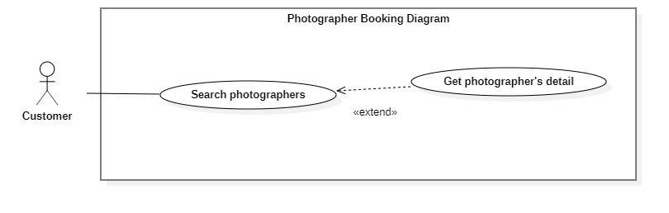

***Figure 8 - <Customer> Get photographer's Detail***

|  |  |  |  |
| --- | --- | --- | --- |
| UC ID and Name: | **PBS-UC-04 Get photographer’s detail** | | |
| Created By: | Truong Ngoc My | Date Created: | 08/10/2020 |
| Primary Actor: | Customer | Secondary Actors: |  |
| Trigger: | The customer taps the photographer or photographer icon. | | |
| Description: | The customer needs to view the profile of the photographer. | | |
| Preconditions: | - The customer has been authenticated.  - The customer has opened location service.  - The customer has accessed the Internet.  - The customer is at the “Danh sách photographer” screen. | | |
| Post-conditions: | Success: The system showed the photographer’s page. | | |
| Normal Flow: | |  |  |  | | --- | --- | --- | | **Step** | **Actor Action** | **System Response** | | 1 | The customer taps on the photographer on the result of a list photographer search or photographer view main screen. | The system shows the photographer profile screen with the following information:  - “Mô tả”: introduction or a brief description.  - “Đánh giá” number of people and number of stars: number of bookings.  - “Các album”: album photo of photographer.  - “Nhận xét”: list of feedbacks.  - “Lịch của photographer”: schedule of photographer.  - “Chọn gói dịch vụ bạn muốn”: list of service of photographer, choose option, required.  - “tiếp tục”: button | | | |
| Alternative Flows: | N/A | | |
| Exceptions: | N/A | | |
| Priority: | High | | |
| Frequency of Use: | Always | | |
| Business Rules: | BR-04 | | |
| Other Information: | N/A | | |
| Assumptions: |  | | |

***Table 7 - <Customer> Get photographer's detail use case specification***

1. ***<Customer> Book photographer***

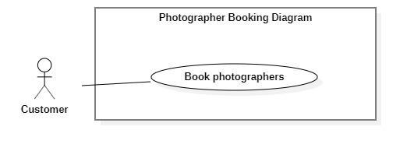

***Figure 9 - <Customer> Book photographer***

|  |  |  |  |
| --- | --- | --- | --- |
| UC ID and Name: | **PBS-UC-05 Book photographer** | | |
| Created By: | Truong Ngoc My | Date Created: | 08/10/2020 |
| Primary Actor: | Customer | Secondary Actors: |  |
| Trigger: | The customer taps the “Tiếp tục” button. | | |
| Description: | The customer can book a photographer . | | |
| Preconditions: | - The customer has been authenticated.  - The customer has selected a photographer and viewed their profile photographer.  - The customer has accessed the Internet. | | |
| Post-conditions: | Success: The system sends requests to the photographer. | | |
| Normal Flow: | |  |  |  | | --- | --- | --- | | **Step** | **Actor Action** | **System Response** | | 1 | The customer taps “Tiếp tục” button after click choose “Chọn gói dịch vụ bạn muốn”. | The system shows the “Đặt lịch với photographer” screen. The customer input following:  - “Photographer”: default.  - “Thời gian chụp”: The customer can choose date and start time.  - “Thời gian nhận”: choose date.  - “Địa điểm”: input text, required.  - “Gói dịch vụ”: the customer can change.  - “Tổng cộng”: price.  - “Đặt dịch vụ”: button | | 2 | The customer taps “Đặt dịch vụ” button | - The system validates inputted data  - The system creates a new request and notifies the chosen photographer.[Exception 1,2] | | | |
| Alternative Flows: | N/A | | |
| Exceptions: | |  |  |  | | --- | --- | --- | | **No** | **Actor Action** | **System Response** | | 1 | The customer book photographer successfully. | System shows an error message : “Gửi yêu cầu thành công” | | 2 | The customer do not choose “Thời gian chụp”, “Thời gian nhận” and “Địa điểm”. | System shows an error message : “Bạn chưa chọn thông tin” | | | |
| Priority: | High | | |
| Frequency of Use: | Sometimes | | |
| Business Rules: | BR-01, BR-02, BR-07, BR-15 | | |
| Other Information: | N/A | | |
| Assumptions: |  | | |

***Table 8 - <Customer> Book photographer use case specification***

1. ***<Customer> Review photographers***

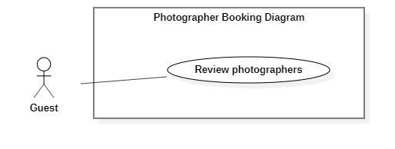

***Figure 10 - <Customer> Review photographers***

|  |  |  |  |
| --- | --- | --- | --- |
| UC ID and Name: | **PBS-UC-06 Review photographers** | | |
| Created By: | Truong Ngoc My | Date Created: | 08/10/2020 |
| Primary Actor: | Customer | Secondary Actors: |  |
| Trigger: | The customer taps “Đánh giá” to request successfully history. | | |
| Description: | The customer needs to write a comment and rating to the photographer service. | | |
| Preconditions: | - The customer has been authenticated.  - The customer book photographer successfully.  - The customer has accessed the Internet. | | |
| Post-conditions: | Success: The system shows comments and ratings of the customer on the photographer page. | | |
| Normal Flow: | |  |  |  | | --- | --- | --- | | **Step** | **Actor Action** | **System Response** | | 1 |  | After the request’s status is updated to “Đã hoàn thành”, “Đánh giá” button and “Bỏ qua” button is shown. | | 2 | The customer taps “Đánh giá” button | The system will go to “Nhận xét” on the photographer page. The customer input with the following:  - star icon: The customer choose star  -“Bình luận”: Text input, optional | | 3 | The customer taps “Gửi” button | - The system validates inputted data [Exception1,2]  - The system shows comments and ratings of customers. | | | |
| Alternative Flows: | N/A | | |
| Exceptions: | |  |  |  | | --- | --- | --- | | **No** | **Actor Action** | **System Response** | | 1 | Enter many characters. | System shows an error message:  “Bạn chỉ được nhập tối đa 150 ký tự” | | 2 | Enter less character. | System shows an error message:  “Bạn phải nhập tối thiểu 50 ký tự”. | | | |
| Priority: | High | | |
| Frequency of Use: | Sometimes | | |
| Business Rules: | BR-03 | | |
| Other Information: | N/A | | |
| Assumptions: |  | | |

***Table 9 - <Customer> Review photographers use case specification***

1. ***<Customer> Get booking***

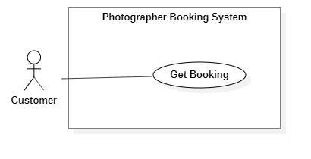

**Figure 11 - <Customer> Get booking**

|  |  |  |  |
| --- | --- | --- | --- |
| UC ID and Name: | **PBS-UC-07 Get booking** | | |
| Created By: | Truong Ngoc My | Date Created: | 08/10/2020 |
| Primary Actor: | Customer | Secondary Actors: | Photographer |
| Trigger: | The customer navigates to the “Hoat động” screen. | | |
| Description: | The customer can view all requests of theirs. | | |
| Preconditions: | - The customer has been authenticated.  - The customer has accessed the Internet.  - The customer book photographer. | | |
| Post-conditions: | Success: The customer can view request history. | | |
| Normal Flow: | |  |  |  | | --- | --- | --- | | Step | Actor Action | System Response | | 1 | The customer navigates to the “Hoạt động” screen. | The system shows a list of requests the customer has made. | | | |
| Alternative Flows: | N/A | | |
| Exceptions: | N/A | | |
| Priority: | Low | | |
| Frequency of Use: | Sometimes | | |
| Business Rules: | N/A | | |
| Other Information: | N/A | | |
| Assumptions: |  | | |

***Table 10 - <Customer> Get booking use case specification***

1. ***<Customer> Edit Booking***

***Figure 12 - <Customer> Edit booking***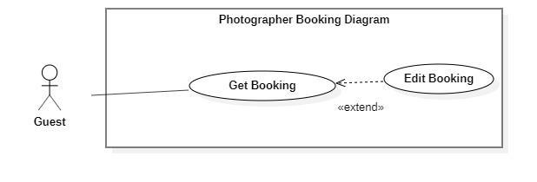

|  |  |  |  |
| --- | --- | --- | --- |
| UC ID and Name: | **PBS-UC-08 Edit booking** | | |
| Created By: | Truong Ngoc My | Date Created: | 08/10/2020 |
| Primary Actor: | Customer | Secondary Actors: |  |
| Trigger: | The customer taps on “Thay đổi” button in the request “Chờ xác nhận”. | | |
| Description: | The customer needs to change information on request. | | |
| Preconditions: | - The customer has been authenticated.  - The customer has accessed the Internet.  - The status of request is “Chờ xác nhận”. | | |
| Post-conditions: | Success: The customer changes a request successfully and the system send request to the photographer. | | |
| Normal Flow: | |  |  |  | | --- | --- | --- | | **Step** | **Actor Action** | **System Response** | | 1 | The customer taps “Chờ xác nhận” request. | The system shows the “Thông tin hoạt động” screen:  -“Trạng thái, thời gian & địa điểm” to include: “Trạng thái”, “Thời gian”, “Thời gian tác nghiệp dự kiến”, “Thời gian nhận ảnh”, “Địa điểm”.  - “Thông tin photographer”: name photographer and rating.  - “Thông tin gói dịch vụ” to include: “tên gói”, “Mô tả”, “Bao gồm các dịch vụ”, “Tổng cộng”  - “Thay đổi”: button  - “Hủy”: button | | 2 | The customer taps “Thay đổi” button on the item. | The system shows the “Thông tin đặt lịch” screen. The customer input following:  - “Photographer”: default.  - “Thời gian chụp”: The customer can choose date and start time.  - “Thời gian nhận”: choose date.  - “Địa điểm”: input text, required.  - “Gói dịch vụ”: the customer can change.  - “Tổng cộng”: price.  - “Xác nhận”: button  - “Hủy”: button | | 3 | The customer taps the “Xác nhận” button. | - The system validates inputted data [Exception 2]  - The system creates a new request and notifies the chosen photographer.[Exception 1] | | | |
| Alternative Flows: | N/A | | |
| Exceptions: | |  |  |  | | --- | --- | --- | | **No** | **Actor Action** | **System Response** | | 1 | The customer book photographer successfully. | System shows an error message : “Gửi yêu cầu thành công” | | 2 | The customer do not choose “Thời gian” and “Địa điểm”. | System shows an error message : “Bạn chưa chọn thông tin” | | | |
| Priority: | Medium | | |
| Frequency of Use: | Sometimes | | |
| Business Rules: | BR-02, BR-04, BR-07, BR-15 | | |
| Other Information: | N/A | | |
| Assumptions: |  | | |

***Table 11- <Customer> Edit booking use case specification***

1. ***<Customer> Cancel booking***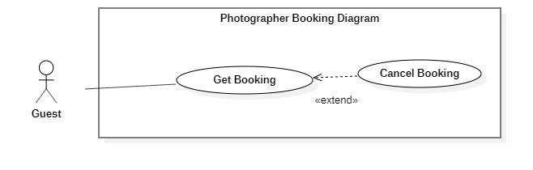

***Figure 13 - <Customer> Cancel booking***

|  |  |  |  |
| --- | --- | --- | --- |
| UC ID and Name: | **PBS-UC-09 Cancel booking** | | |
| Created By: | Truong Ngoc My | Date Created: | 08/10/2020 |
| Primary Actor: | Customer | Secondary Actors: |  |
| Trigger: | The customer taps “Hủy” button on the booking detail. | | |
| Description: | The customer needs to cancel their booking . | | |
| Preconditions: | - The customer has been authenticated.  - The customer has accessed the Internet.  - The status of request is “Chờ xác nhận” or “Sắp diễn ra”. | | |
| Post-conditions: | Success: the customer cancels booking successfully. | | |
| Normal Flow: | |  |  |  | | --- | --- | --- | | **Step** | **Actor Action** | **System Response** | | 1 | The customer taps “Chờ xác nhận” request. | The system shows the “Thông tin hoạt động” screen:  -“Trạng thái, thời gian & địa điểm” to include: “Trạng thái”, “Thời gian”, “Thời gian tác nghiệp dự kiến”, “Thời gian nhận ảnh”, “Địa điểm”.  - “Thông tin photographer”: name photographer and rating.  - “Thông tin gói dịch vụ” to include: “tên gói”, “Mô tả”, “Bao gồm các dịch vụ”, “Tổng cộng”  - “Thay đổi”: button  - “Hủy”: button | | 2 | The customer taps “Hủy” button. | The system shows notifies the chosen customer: [Exception 2]  - “Có”: button  - “Không”: button | | 3 | The customer taps the “Có” button. | - The system update requests the chosen photographer. | | | |
| Alternative Flows: | |  |  |  | | --- | --- | --- | | **Step** | **Actor Action** | **System Response** | | 1 | The customer taps the “Sắp diễn ra” request. | The system shows the “Thông tin hoạt động” screen:  -“Trạng thái, thời gian & địa điểm” to include: “Trạng thái”, “Thời gian”, “Thời gian tác nghiệp dự kiến”, “Thời gian nhận ảnh”, “Địa điểm”.  - “Thông tin photographer”: name photographer and rating.  - “Thông tin gói dịch vụ” to include: “tên gói”, “Mô tả”, “Bao gồm các dịch vụ”, “Tổng cộng”  - “Thay đổi”: button  - “Hủy”: button | | 2 | The customer taps “Hủy” button. | The system shows notifies the chosen customer: [Exception 2]  - “Có”: button  - “Không”: button | | 3 | The customer taps the “Có” button. | - The system update requests the chosen photographer. | | 4 |  | The system shows “Hủy cuộc hẹn” popup. The customer input following:  -”Hủy cuộc hẹn”: input text “Lý do hủy cuộc hẹn của bạn là gì”, required.  - “xác nhận”: button | | 5 | The customer input reason and táp “Xác nhận” button. | The system update requests the chosen photographer. | | | |
| Exceptions: | |  |  |  | | --- | --- | --- | | **No** | **Actor Action** | **System Response** | | 1 | The customer taps “Hủy” button. | System shows an error message : “Bạn có muốn hủy lần đặt photographer này không?” | | | |
| Priority: | High | | |
| Frequency of Use: | Sometimes | | |
| Business Rules: | BR-05, BR-06, BR-16 | | |
| Other Information: | N/A | | |
| Assumptions: |  | | |

***Table 12 - <Customer>Cancel booking use case specification***

#### c. <Photographer> Overview Use Case

***Figure 14 - <Photographer> Overview use case***

1. ***<Photographer> Get Booking***



***Figure 15 - <Photographer> Get booking***

|  |  |  |  |
| --- | --- | --- | --- |
| UC ID and Name: | **PBS-UC-10 Get booking** | | |
| Created By: | Truong Ngoc My | Date Created: | 08/10/2020 |
| Primary Actor: | Photographer | Secondary Actors: |  |
| Trigger: | Photographers navigates to the “Trang chủ” in Photographer’s application | | |
| Description: | The photographer can view a list of their bookings including all status. | | |
| Preconditions: | - The photographer has been authenticated.  - The photographer has access to the Internet. | | |
| Post-conditions: | Success: the system shows lists of requests on the “Lịch làm việc của tôi” screen. | | |
| Normal Flow: | |  |  |  | | --- | --- | --- | | **Step** | **Actor Action** | **System Response** | | 1 |  | The system shows all requests of customer to the main screen of photographer. | | | |
| Alternative Flows: | N/A | | |
| Exceptions: | N/A | | |
| Priority: | High | | |
| Frequency of Use: | Always | | |
| Business Rules: | N/A | | |
| Other Information: | N/A | | |
| Assumptions: |  | | |

***Table 13 - <Photographer>Get booking use case specification***

1. ***<Photographer> Accept Booking***

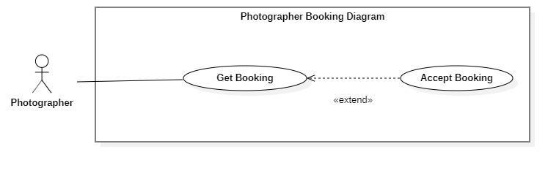

***Figure 16 - <Photographer> Accept Booking***

|  |  |  |  |
| --- | --- | --- | --- |
| UC ID and Name: | **PBS-UC-11 Accept booking** | | |
| Created By: | Truong Ngoc My | Date Created: | 08/10/2020 |
| Primary Actor: | Photographer | Secondary Actors: |  |
| Trigger: | The photographer taps the “Đồng ý” button. | | |
| Description: | The photographer can accept requests from the customer. | | |
| Preconditions: | - The photographer has been authenticated.  - The photographer has access to the Internet.  - The status of request is “Chờ xác nhận”. | | |
| Post-conditions: | Success: the system change status of request is “Sắp diễn ra”. | | |
| Normal Flow: | |  |  |  | | --- | --- | --- | | **Step** | **Actor Action** | **System Response** | | 1 | The photographer taps the “Đồng ý” button when dragging the request to the left. | - The system will change the status of request to “Sắp diễn ra”.  - The system sends notifications to the customer. [Exception 1] | | | |
| Alternative Flows: | |  |  |  | | --- | --- | --- | | **Step** | **Actor Action** | **System Response** | | 1 | The photographer tabs the request “Chờ xác nhận” status. | The system shown detail of request :  - “Trạng thái, thời gian & địa điểm”: text  - “Thông tin khách hàng”: text  - “Thông tin gói dịch vụ”: text  - “Đồng ý”: button  - “Hủy”: button | | 2 | The photographer taps the “Đồng ý” button | - The system will change the status of request to “Sắp diễn ra”.  - The system sends notifications to the customer. [Exception 1] | | | |
| Exceptions: | |  |  |  | | --- | --- | --- | | **No** | **Actor Action** | **System Response** | | 1 | The system sends notifications to the customer. | System shows an error message : “Yêu cầu của bạn đã được xác nhận” | | | |
| Priority: | High | | |
| Frequency of Use: | Always | | |
| Business Rules: | BR-01 | | |
| Other Information: | N/A | | |
| Assumptions: |  | | |

***Table 14 - <Photographer> Accept Booking use case specification***

1. ***<Photographer> Decline Booking***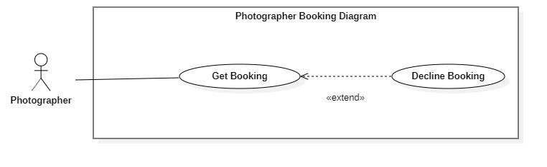

***Figure 17 - <Photographer> Decline Booking***

|  |  |  |  |
| --- | --- | --- | --- |
| UC ID and Name: | **PBS-UC-12 Decline booking** | | |
| Created By: | Truong Ngoc My | Date Created: | 08/10/2020 |
| Primary Actor: | Photographer | Secondary Actors: |  |
| Trigger: | The photographer taps “Hủy” button. | | |
| Description: | The photographer can decline a request from the customer. | | |
| Preconditions: | - The photographer has been authenticated.  - The photographer has access to the Internet.  - The status of request is “Chờ xác nhận”. | | |
| Post-conditions: | Success: the system sends notifications to the customer.F | | |
| Normal Flow: | |  |  |  | | --- | --- | --- | | **Step** | **Actor Action** | **System Response** | | 1 | The photographer taps the “Hủy” button when dragging the request to the left. | - The system sends notification to the customer. [Exception 1] | | | |
| Alternative Flows: | |  |  |  | | --- | --- | --- | | **Step** | **Actor Action** | **System Response** | | 1 | The photographer tabs the request “Chờ xác nhận” status. | The system shown detail of request :  - “Trạng thái, thời gian & địa điểm”: text  - “Thông tin khách hàng”: text  - “Thông tin gói dịch vụ”: text  - “Đồng ý”: button  - “Hủy”: button | | 2 | The photographer taps the “Hủy” button | The system sends notification to the customer. [Exception 1] | | | |
| Exceptions: | |  |  |  | | --- | --- | --- | | **No** | **Actor Action** | **System Response** | | 1 | The system sends notification to the customer. | System shows an error message : “Yêu cầu của bạn đã bị từ chối” | | | |
| Priority: | High | | |
| Frequency of Use: | Sometimes | | |
| Business Rules: | BR-01 | | |
| Other Information: | N/A | | |
| Assumptions: |  | | |

***Table 15 - <Photographer> Cancel Booking Use Case Specification***

1. ***<Photographer> Edit working calendar***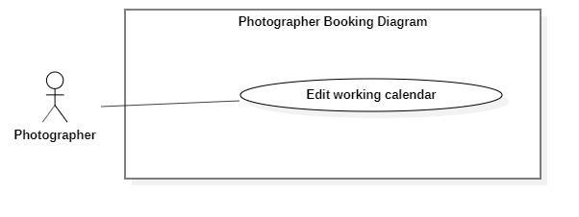

***Figure 18 - <Photographer> Edit working calendar***

|  |  |  |  |
| --- | --- | --- | --- |
| UC ID and Name: | **PBS-UC-13 Edit working calendar** | | |
| Created By: | Truong Ngoc My | Date Created: | 08/10/2020 |
| Primary Actor: | Photographer | Secondary Actors: |  |
| Trigger: | The photographer taps the date in the calendar. | | |
| Description: | The photographer can edit the working calendar. | | |
| Preconditions: | - The photographer has been authenticated.  - The photographer has access to the Internet. | | |
| Post-conditions: | Success: the system updates the calendar of photographers. | | |
| Normal Flow: | |  |  |  | | --- | --- | --- | | **Step** | **Actor Action** | **System Response** | | 1 | The photographer taps day. | The system shows details of day. Photographer can view:  - A list request of customer following start time | | 2 | The photographer taps day in the future and makes an empty request. |  | | | |
| Alternative Flows: | N/A | | |
| Exceptions: | N/A | | |
| Priority: | Medium | | |
| Frequency of Use: | Sometimes | | |
| Business Rules: |  | | |
| Other Information: | N/A | | |
| Assumptions: |  | | |

**Table 16 - <Photographer>Edit Working Calendar Use Case Specification**

1. ***<Photographer> Get customer’s review***

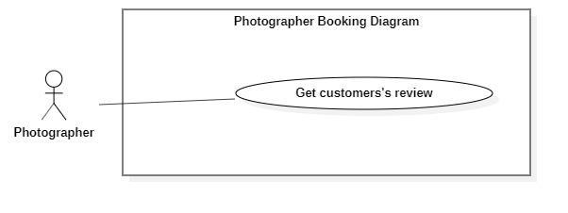

***Figure 19 - <Photographer> Get customer's review***

|  |  |  |  |
| --- | --- | --- | --- |
| UC ID and Name: | **PBS-UC-14 Get customer’s review** | | |
| Created By: | Truong Ngoc My | Date Created: | 08/10/2020 |
| Primary Actor: | Photographer | Secondary Actors: |  |
| Trigger: | The photographer taps “Trang cá nhân” page. | | |
| Description: | The photographer can view the customer's review. | | |
| Preconditions: | - The photographer has been authenticated.  - The photographer has access to the Internet. | | |
| Post-conditions: | Success: the system sends notifications to the customer. | | |
| Normal Flow: | |  |  |  | | --- | --- | --- | | Step | Actor Action | System Response | | 1 | The photographer taps “Trang cá nhân” page. | - The system shows the “Trang cá nhân” page of the photographer. | | | |
| Alternative Flows: | N/A | | |
| Exceptions: | N/A | | |
| Priority: | Medium | | |
| Frequency of Use: | Sometimes | | |
| Business Rules: | BR-08 | | |
| Other Information: | N/A | | |
| Assumptions: |  | | |

***Table 17 - <Photographer> Get Customer’s Review Use Case Specification***

1. ***<Photographer> Add service***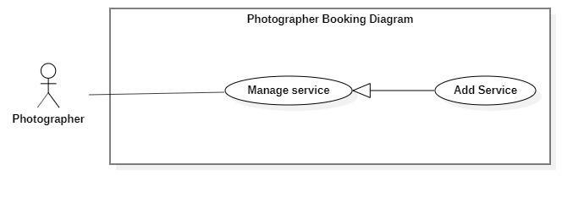

***Figure 20 - <Photographer> Add service***

|  |  |  |  |
| --- | --- | --- | --- |
| UC ID and Name: | **PBS-UC-15 Add Service** | | |
| Created By: | Truong Ngoc My | Date Created: | 08/10/2020 |
| Primary Actor: | Photographer | Secondary Actors: |  |
| Trigger: | The photographer taps add icon on the “Trang cá nhân” screen. | | |
| Description: | The photographer can add service. | | |
| Preconditions: | - The photographer has been authenticated.  - The photographer has access to the Internet. | | |
| Post-conditions: | Success: the photographer adds service to the “Chọn gói dịch vụ bạn muốn” the detail screen. | | |
| Normal Flow: | |  |  |  | | --- | --- | --- | | Step | Actor Action | System Response | | 1 | The photographer taps navigates “Dịch vụ” screen and taps add icon. | The system shows list of services the photographer has added with the following information:  - “Tên dịch vụ”: input text, required.  - “Giá thành dịch vụ”: input text, required  - “Thời gian tác nghiệp”: input text, required  - “Chi tiết dịch vụ”: input text, required.  - “Thêm dịch vụ”: button | | 2 | The photographer taps “Thêm dịch vụ” button | - The system validates inputted data [Exception 1].  - The system sends notifications to the customer. [Exception 2]. | | | |
| Alternative Flows: | N/A | | |
| Exceptions: | |  |  |  | | --- | --- | --- | | No | Actor Action | System Response | | 1 | “Tên dịch vụ”, “Giá thành dịch vụ”, “Chi tiết dịch vụ” is empty | System shows an error message : “Thông tin này bắt buộc” | | 2 | Add service successfully | System shows an error message:  “Thêm dịch vụ thành công”. | | | |
| Priority: | High | | |
| Frequency of Use: | Sometimes | | |
| Business Rules: |  | | |
| Other Information: | N/A | | |
| Assumptions: |  | | |

***Table 18 - <Photographer> Add Service Use case Specification***

1. ***<Photographer> Edit service***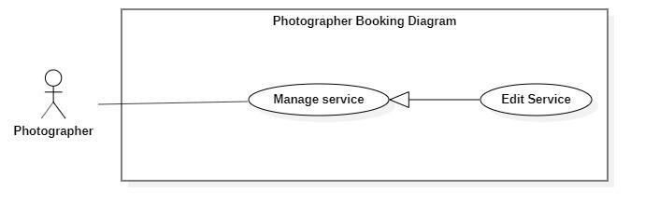

***Figure 21 - <Photographer> Edit Service***

|  |  |  |  |
| --- | --- | --- | --- |
| UC ID and Name: | **PBS-UC-16 Edit service** | | |
| Created By: | Truong Ngoc My | Date Created: | 08/10/2020 |
| Primary Actor: | Photographer | Secondary Actors: |  |
| Trigger: | The photographer taps “Thay đổi” button on “Gói dịch vụ” detail page. | | |
| Description: | The photographer can edit the service available. | | |
| Preconditions: | - The photographer has been authenticated.  - The photographer has access to the Internet.  - The service pack available. | | |
| Post-conditions: | Success: the photographer edit service successfully and update “Các gói dịch vụ bạn muốn” to the detail photographer screen. | | |
| Normal Flow: | |  |  |  | | --- | --- | --- | | **Step** | **Actor Action** | **System Response** | | 1 | The photographer taps “Dịch vụ của tôi” . | The system shows list of services the photographer has view with the following information:  - “Tên dịch vụ”: input text, required.  - “Giá thành dịch vụ”: input text, required  - “Thời gian tác nghiệp”: input text, required  - “Chi tiết dịch vụ”: input text, required.  - “Chỉnh sửa”: button  - “Xóa”: button | | 2 | The photographer taps “Chỉnh sửa” button | The system shows list of services the photographer input with the following information:  - “Tên dịch vụ”: input text, required.  - “Giá thành dịch vụ”: input text, required  - “Thời gian tác nghiệp”: input text, required  - “Chi tiết dịch vụ”: input text, required.  - “Xác nhận”: button  - Hủy”: button | | 3 | The photographer taps “Xác nhận” button | - The system validates inputted data [Exception 1].  - The system sends nontifies to the customer. [Exception 2]. | | | |
| Alternative Flows: | N/A | | |
| Exceptions: | |  |  |  | | --- | --- | --- | | **No** | **Actor Action** | **System Response** | | 2 | “Tên dịch vụ”, “Giá thành dịch vụ”, “Chi tiết dịch vụ” is empty | System shows an error message : “Thông tin này bắt buộc” | | 3 | Edit service successfully | System shows an error message:  “Thay đổi thành công”. | | | |
| Priority: | Medium | | |
| Frequency of Use: | Sometimes | | |
| Business Rules: |  | | |
| Other Information: | N/A | | |
| Assumptions: |  | | |

***Table 19 - <Photographer>Edit service use case specification***

1. ***<Photographer> Remove Service***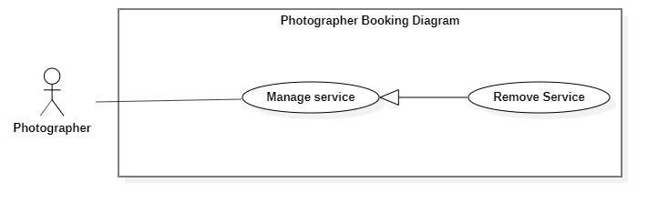

***Figure 22 - <Photographer> Remove Service***

|  |  |  |  |
| --- | --- | --- | --- |
| UC ID and Name: | **PBS-UC-16 Remove service** | | |
| Created By: | Truong Ngoc My | Date Created: | 08/10/2020 |
| Primary Actor: | Photographer | Secondary Actors: |  |
| Trigger: | The photographer taps “Xóa” button in the “Dịch vụ của tôi” screen. | | |
| Description: | The photographer can remove service. | | |
| Preconditions: | - The photographer has been authenticated.  - The photographer has access to the Internet.  - The service pack available. | | |
| Post-conditions: | Success: the photographer removes service successfully and update “Các gói dịch vụ bạn muốn” on the detail screen. | | |
| Normal Flow: | |  |  |  | | --- | --- | --- | | **Step** | **Actor Action** | **System Response** | | 1 | The photographer taps navigates “Dịch vụ” . | The system shows list of services the photographer has view with the following information:  - “Tên dịch vụ”: input text, required.  - “Giá thành dịch vụ”: input text, required  - “Thời gian tác nghiệp”: input text, required  - “Chi tiết dịch vụ”: input text, required.  - “Xác nhận”: button  - Hủy”: button | | 2 | The photographer taps the “Xóa” button. | The system shows notifications to the photographer. [Exception 1] | | 3 | The photographer taps “Xác nhận” button | The system sends notifications to the customer. [Exception 2]. | | | |
| Alternative Flows: | N/A | | |
| Exceptions: | |  |  |  | | --- | --- | --- | | No | Actor Action | System Response | | 1 | The photographer taps the “Xóa” button. | System shows an error message : “Bạn có muốn xóa dịch vụ này?” | | 2 | Remove service successfully | System shows an error message:  “Xóa dịch vụ thành công”. | | | |
| Priority: | Medium | | |
| Frequency of Use: | Sometimes | | |
| Business Rules: |  | | |
| Other Information: | N/A | | |
| Assumptions: |  | | |

1. ***<Photographer>Add album***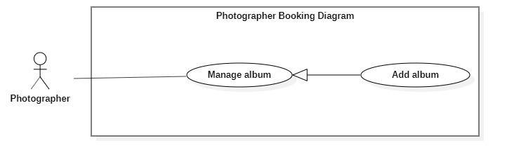

***Figure 23 - <Photographer> Add Album***

|  |  |  |  |
| --- | --- | --- | --- |
| UC ID and Name: | **PBS-UC-17 Add Album** | | |
| Created By: | Truong Ngoc My | Date Created: | 08/10/2020 |
| Primary Actor: | Photographer | Secondary Actors: |  |
| Trigger: | The photographer taps the add album icon on the “Album” screen. | | |
| Description: | The photographer can add albums. | | |
| Preconditions: | - The photographer has been authenticated.  - The photographer has access to the Internet. | | |
| Post-conditions: | Success: the photographer adds the album successfully and update “Các album của photographer” on the detail screen. | | |
| Normal Flow: | |  |  |  | | --- | --- | --- | | **Step** | **Actor Action** | **System Response** | | 1 | The photographer taps the “Album” screen and taps the added album icon. | The system shows list of album available the photographer has added photo with the following information:  - “Tên album”: input text, required.  - “Hình ảnh”: choose the device.  - “Thể loại”: input text, required  - “Địa điểm chụp”: input text, required.  - “Thêm album”: button | | 2 | The photographer taps “Thêm album” button | - The system validates inputted data [Exception 1].  - The system sends notifications to the customer. [Exception 2]. | | | |
| Alternative Flows: | N/A | | |
| Exceptions: | |  |  |  | | --- | --- | --- | | **No** | **Actor Action** | **System Response** | | 1 | “Tên album” and “Hình ảnh”, “thể loại” is empty | System shows an error message : “Thông tin này bắt buộc” | | 2 | Add album successfully | System shows an error message:  “Thêm album thành công”. | | | |
| Priority: | Medium | | |
| Frequency of Use: | Sometimes | | |
| Business Rules: |  | | |
| Other Information: | N/A | | |
| Assumptions: | . | | |

***Table 20 - <Photographer> Add album use case specification***

1. ***<Photographer> Edit album***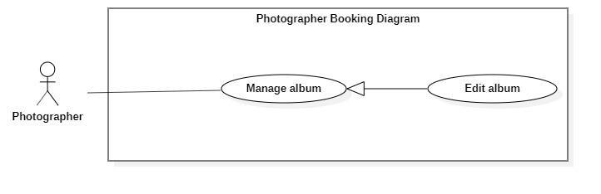

***Figure 24 - <Photographer> Edit Album***

|  |  |  |  |
| --- | --- | --- | --- |
| UC ID and Name: | **PBS-UC-18 Edit Album** | | |
| Created By: | Truong Ngoc My | Date Created: | 08/10/2020 |
| Primary Actor: | Photographer | Secondary Actors: |  |
| Trigger: | The photographer taps “Album” detail and taps “Chỉnh sửa” button. | | |
| Description: | The photographer can edit the album of their. | | |
| Preconditions: | - The photographer has been authenticated.  - The photographer has access to the Internet.  - The album available. | | |
| Post-conditions: | Success: the photographer edited the album successfully and update “Các album của photographer” on the detail screen. | | |
| Normal Flow: | |  |  |  | | --- | --- | --- | | **Step** | **Actor Action** | **System Response** | | 1 | The photographer taps “Album”. | The system shows a list of photos available. The photographer has view photo with the following information:  - “Tên album”: input text, required.  - “Hình ảnh”: choose the device.  - “Thể loại”: input text, required  - “Địa điểm chụp”: input text, required.  - “Xóa”: button  - “Chỉnh sửa”: button | | 2 | The photographer taps “Chỉnh sửa” button. | The system shows a detailed photo screen. The photographer has edit album with the following information:  - “Tên album”: input text, required.  - “Hình ảnh”: choose the device.  - “Thể loại”: input text, required  - “Địa điểm chụp”: input text, required.  - “Xác nhận”: button  -”Hủy”: button | | 3 | The photographer taps “Xác nhận” button | - The system validates inputted data [Exception 1].  - The system sends notifications to the customer. [Exception 2]. | | | |
| Alternative Flows: | N/A | | |
| Exceptions: | |  |  |  | | --- | --- | --- | | **No** | **Actor Action** | **System Response** | | 1 | “Tên album” and “Hình ảnh”, “thể loại” is empty | System shows an error message : “Thông tin này bắt buộc” | | 2 | The photographer taps the “Xác nhận” button. | System shows an error message:  “Thay đổi album thành công”. | | | |
| Priority: | Medium | | |
| Frequency of Use: | Sometimes | | |
| Business Rules: |  | | |
| Other Information: | N/A | | |
| Assumptions: |  | | |

***Table 21 - <Photographer> Edit Album Use Case Specification***

1. ***<Photographer> Remove album***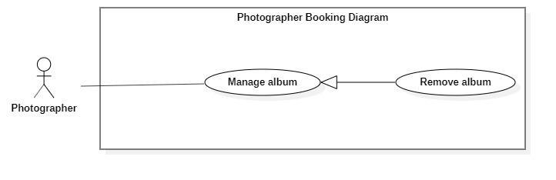

***Figure 25 - <Photographer> Remove Album***

|  |  |  |  |
| --- | --- | --- | --- |
| UC ID and Name: | **PBS-UC-19 Remove Album** | | |
| Created By: | Truong Ngoc My | Date Created: | 08/10/2020 |
| Primary Actor: | Photographer | Secondary Actors: |  |
| Trigger: | The photographer taps the “Xóa” button. | | |
| Description: | The photographer can remove the album. | | |
| Preconditions: | - The photographer has been authenticated.  - The photographer has access to the Internet.  - The album available. | | |
| Post-conditions: | Success: the photographer removed the album successfully and update “Các album của photographer” on the detail screen. | | |
| Normal Flow: | |  |  |  | | --- | --- | --- | | Step | Actor Action | System Response | | 1 | The photographer taps the “Xóa” button. | The system shows notifies to the photographer.[Exception 1] | | 2 | The photographer taps the “Xác nhận” button. | The system shows notifications to the photographer. [Exception 2]. | | | |
| Alternative Flows: | N/A | | |
| Exceptions: | |  |  |  | | --- | --- | --- | | No | Actor Action | System Response | | 1 | The photographer taps the “Xóa” button. | System shows an error message : “Bạn có muốn xóa album này?” | | 2 | The photographer taps the “Xác nhận” button. | System shows an error message:  “Xóa album thành công”. | | | |
| Priority: | Medium | | |
| Frequency of Use: | Sometimes | | |
| Business Rules: |  | | |
| Other Information: | N/A | | |
| Assumptions: |  | | |

#### d. <Authenticated User> Overview Use Case

***Figure 26 - <Authenticated User> Overview Use Case***

1. ***<Authenticated User> Get profile***

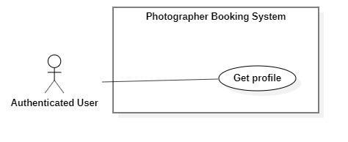

***Figure 27 - <Authenticated User> Get profile***

|  |  |  |  |
| --- | --- | --- | --- |
| UC ID and Name: | **PBS-UC-20 Get profile** | | |
| Created By: | Truong Ngoc My | Date Created: | 08/10/2020 |
| Primary Actor: | Authenticated User | Secondary Actors: |  |
| Trigger: | The Authenticated User navigates to “Cài đặt” and taps the “Thông tin cá nhân” screen to view the profile. | | |
| Description: | The authenticated user can view their profile. | | |
| Preconditions: | The authenticated user has accessed the Internet. | | |
| Post-conditions: | Success: The Authenticated User can view his/her profile successfully. | | |
| Normal Flow: | |  |  |  | | --- | --- | --- | | Step | Actor Action | System Response | | 1 | The Authenticated User navigates to the “Cài đặt” and taps the “Thông tin cá nhân” screen to view the profile. | The system shows “Thông tin cá nhân” screen with the following information:  - “Avatar”: image.  - “Họ và tên”: text input, editable  - “Địa chỉ”: text input, editable  - “Số điện thoại”: phone number input  - “Cập nhật” button | | | |
| Alternative Flows: | N/A | | |
| Exceptions: | N/A | | |
| Priority: | Medium | | |
| Frequency of Use: | Sometimes | | |
| Business Rules: | N/A | | |
| Other Information: | N/A | | |
| Assumptions: |  | | |

***Table 22 - <Authenticated User> Get profile use case specification***

1. ***<Authenticated User> Edit profile***

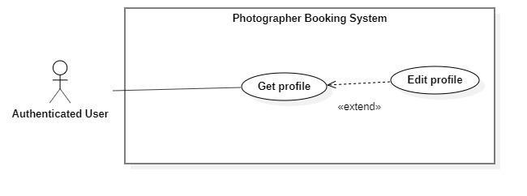

***Figure 28 - <Authenticated User> Edit profile***

|  |  |  |  |
| --- | --- | --- | --- |
| UC ID and Name: | **PBS-UC-21 Edit profile** | | |
| Created By: | Truong Ngoc My | Date Created: | 08/10/2020 |
| Primary Actor: | Authenticated User | Secondary Actors: |  |
| Trigger: | The Authenticated User taps “Cập nhật” of “Thông tin cá nhân” screen to view profile. | | |
| Description: | The authenticated user can update their profile. | | |
| Preconditions: | The authenticated user has accessed the Internet. | | |
| Post-conditions: | Success: The Authenticated User can update his/her profile successfully. | | |
| Normal Flow: | |  |  |  | | --- | --- | --- | | Step | Actor Action | System Response | | 1 | The Authenticated User taps the“Thông tin cá nhân” screen to view the profile. | The system shows “Thông tin cá nhân” screen and view with the following information:  - “Avatar”: image  - “Họ và tên”: text input, editable  - “Địa chỉ: text input, editable  - “Số điện thoại”: phone number input.  - “Cập nhật” button: is used to update information. | | 2 | The Authenticated User updates information and clicks “Cập nhật” to confirm | The system shows “Thông tin cá nhân” screen and view with the following information:  - “Avatar”: image  - “Họ và tên”: text input, editable  - “Địa chỉ: text input, editable  - “Số điện thoại”: phone number input.  - “Xác nhận” button  - “Hủy”: button | | 3 | The Authenticated User updates information and clicks “Xác nhận” to confirm | The system validates inputted data  The system updates the profile and shows message  [Exception 1, 2] | | | |
| Alternative Flows: | N/A | | |
| Exceptions: | |  |  |  | | --- | --- | --- | | No | Actor Action | System Response | | 1 | “Họ và tên”, “địa chỉ”, “Số điện thoại” is empty | System shows an error message : “Thông tin này bắt buộc”. | | 2 | Update successfully | System shows an error message : “Cập nhật thông tin thành công”. | | | |
| Priority: | Medium | | |
| Frequency of Use: | Sometimes | | |
| Business Rules: |  | | |
| Other Information: | N/A | | |
| Assumptions: |  | | |

***Table 23 - <Authenticated User> Edit profile use case specification***

1. ***<Authenticated User> Change password***

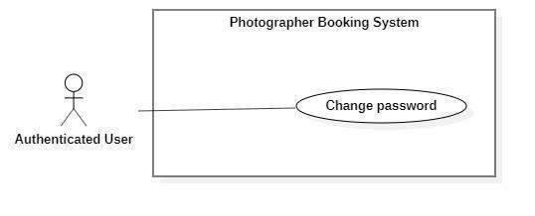

***Figure 29 - <Authenticated User> Change password***

|  |  |  |  |
| --- | --- | --- | --- |
| UC ID and Name: | **PBS-UC-22 Change password** | | |
| Created By: | Truong Ngoc My | Date Created: | 08/10/2020 |
| Primary Actor: | Authenticated User | Secondary Actors: |  |
| Trigger: | The Authenticated User navigates to “Cài đặt” screen and taps the “Thay đổi mật khẩu” to change password. | | |
| Description: | The authenticated user can change their password. | | |
| Preconditions: | The authenticated user has accessed the Internet. | | |
| Post-conditions: | Success: The Authenticated User can change password successfully and logout the system. | | |
| Normal Flow: | |  |  |  | | --- | --- | --- | | **Step** | **Actor Action** | **System Response** | | 1 | The Authenticated User navigates to “Cài đặt” screen and taps the “Thay đổi mật khẩu” | The system shows “Đổi mật khẩu” screen with the following inputs:  - “Mật khẩu hiện tại”: current password, password input, required  - “Mật khẩu mới”: new password, password input, required  - “Xác nhận mật khẩu mới”: confirm new password, password input, required  - “xác nhận” button.  - “Hủy”: button | | 2 | The Authenticated User inputs information and taps “Xác nhận” to confirm. | The system validates inputted data  [Exception 1, 2]  The system updates the profile and shows message  [Exception 3] | | | |
| Alternative Flows: | N/A | | |
| Exceptions: | |  |  |  | | --- | --- | --- | | No | Actor Action | System Response | | 1 | “Mật khẩu hiện tại”, “Mật khẩu mới”, “xác nhận mật khẩu mới” is empty | System shows an error message : “Thông tin này bắt buộc”. | | 2 | New password and confirm password do not match. | System shows an error message: “Mật khẩu nhập lại chưa chính xác” | | 3 | Current password is invalid | System shows an error message: “Mật khẩu hiện tại chưa chính xác” | | | |
| Priority: | Medium | | |
| Frequency of Use: | Sometimes | | |
| Business Rules: |  | | |
| Other Information: | N/A | | |
| Assumptions: |  | | |

**Table 24 - <Authenticated User> Change Password Use Case specification**

1. ***<Authenticated User> Logout***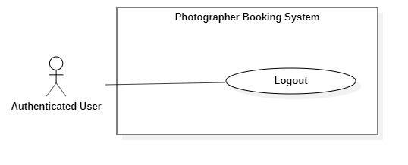

***Figure 30 - <Authenticated User> Logout***

|  |  |  |  |
| --- | --- | --- | --- |
| UC ID and Name: | **PBS-UC-23 Logout** | | |
| Created By: | Truong Ngoc My | Date Created: | 08/10/2020 |
| Primary Actor: | Authenticated User | Secondary Actors: |  |
| Trigger: | The Authenticated User navigates to “Cài đặt” screen and taps the “Đăng xuất” to log out. | | |
| Description: | The system allows the Authenticated User to log out | | |
| Preconditions: | The authenticated user has accessed the Internet. | | |
| Post-conditions: | Success: The Authenticated User can log out successfully. | | |
| Normal Flow: | |  |  |  | | --- | --- | --- | | Step | Actor Action | System Response | | 1 | The Authenticated User navigates to “Cài đặt” screen to log out | The system deletes the login session and navigates the back to “Đăng nhập” screen. | | | |
| Alternative Flows: | N/A | | |
| Exceptions: | N/A | | |
| Priority: | Medium | | |
| Frequency of Use: | Always | | |
| Business Rules: | N/A | | |
| Other Information: | N/A | | |
| Assumptions: |  | | |

***Table 25 - <Authenticated User> Logout use case specification***

#### e. <Admin> Overview Use Case

***Figure 31 - <Admin> Overview Use Case***

1. ***<Admin> Get user’s activity***

***Figure 32 - <Admin> Get user's activity***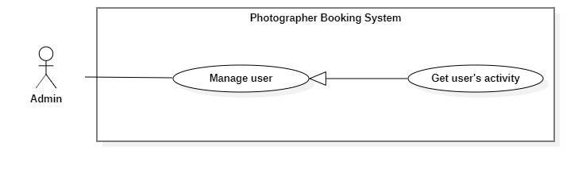

|  |  |  |  |
| --- | --- | --- | --- |
| UC ID and Name: | **PBS-UC-24 Get user’s activity** | | |
| Created By: | Truong Ngoc My | Date Created: | 08/10/2020 |
| Primary Actor: | Admin | Secondary Actors: |  |
| Trigger: | The admin taps navigates “Hoạt động” screen. | | |
| Description: | The admin can view a list of the user's activity. | | |
| Preconditions: | - User must be an Admin.  - User has logged into the website. | | |
| Post-conditions: | Success: The admin can view a table and a list of the user's activity successfully. | | |
| Normal Flow: | |  |  |  | | --- | --- | --- | | **Step** | **Actor Action** | **System Response** | | 1 | The admin taps navigates “Hoạt động” screen. | The system showed a table a list of the user's activity. | | | |
| Alternative Flows: | N/A | | |
| Exceptions: | N/A | | |
| Priority: | Medium | | |
| Frequency of Use: | Always | | |
| Business Rules: | BR-10, BR-11 | | |
| Other Information: | N/A | | |
| Assumptions: |  | | |

***Table 26 - <Admin> Get user's activity use case specification***

1. ***<Admin> Block user***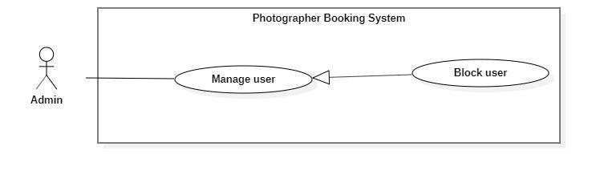

***Figure 33 - <Admin> Block user***

|  |  |  |  |
| --- | --- | --- | --- |
| UC ID and Name: | **PBS-UC-25 Block user** | | |
| Created By: | Truong Ngoc My | Date Created: | 08/10/2020 |
| Primary Actor: | Admin | Secondary Actors: |  |
| Trigger: | The admin tabs “Khóa” button on the “Danh sách người dùng” screen. | | |
| Description: | The admin can block users if the user violates business rules. | | |
| Preconditions: | - User must be an Admin.  - User has logged into the website. | | |
| Post-conditions: | Success: The admin can block users successfully. | | |
| Normal Flow: | |  |  |  | | --- | --- | --- | | **Step** | **Actor Action** | **System Response** | | 1 | The admin tabs “Khóa” button on the “Danh sách người dùng” screen. | The system shows notifications to the admin. [Exception 1]. | | 2 | The admin taps the “Xác nhận” button. | The system shows notifications to the admin. [Exception 2] | | 3 |  | The system sends notifications to the user. [Exception 3]. | | | |
| Alternative Flows: | N/A | | |
| Exceptions: | |  |  |  | | --- | --- | --- | | **No** | **Actor Action** | **System Response** | | 1 | The system shows notifications to the admin. | System shows an error message : “Bạn có muốn khóa người dùng này?”. | | 2 | The admin taps the “Xác nhận” button. | System shows an error message : “Người dùng đã được khóa thành công”. | | 3 | The system sends notifications to the user. | System shows an error message : “Tài khoản của bạn đã bị vi phạm. Vui lòng liên hệ với quản trị viên”. | | | |
| Priority: | High | | |
| Frequency of Use: | Sometimes | | |
| Business Rules: | BR-09 | | |
| Other Information: | N/A | | |
| Assumptions: |  | | |

1. ***<Admin> Unblock user***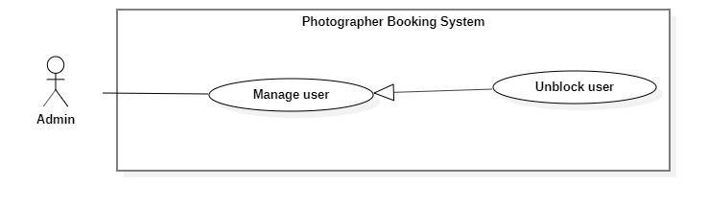

***Figure 34 - <Admin> Unblock user***

|  |  |  |  |
| --- | --- | --- | --- |
| UC ID and Name: | **PBS-UC-26 Unblock user** | | |
| Created By: | Truong Ngoc My | Date Created: | 08/10/2020 |
| Primary Actor: | Admin | Secondary Actors: |  |
| Trigger: | The admin tabs “Mở khóa” button on the “Danh sách người dùng” screen. | | |
| Description: | The admin can unblock users . | | |
| Preconditions: | - User must be an Admin.  - User has logged into the website.  - The user locked. | | |
| Post-conditions: | Success: The admin can unblock users successfully. | | |
| Normal Flow: | |  |  |  | | --- | --- | --- | | **Step** | **Actor Action** | **System Response** | | 1 | The admin tabs “Mở khóa” button on the “Danh sách người dùng” screen. | The system shows notifications to the admin. [Exception 1] | | 2 | The admin taps the “Xác nhận” button. | The system shows notifications to the admin. [Exception 3] | | | |
| Alternative Flows: | N/A | | |
| Exceptions: | |  |  |  | | --- | --- | --- | | **No** | **Actor Action** | **System Response** | | 1 | The system shows notifications to the admin. | System shows an error message : “Bạn có muốn mở khóa người dùng này?”. | | 2 | The admin taps the “Xác nhận” button. | System shows an error message : “Người dùng đã được mở khóa thành công”. | | | |
| Priority: | High | | |
| Frequency of Use: | Sometimes | | |
| Business Rules: | BR-09 | | |
| Other Information: | N/A | | |
| Assumptions: |  | | |

***Table 27 - <Admin> Unblock user use case specification***

1. ***<Admin> Get customer’s review***

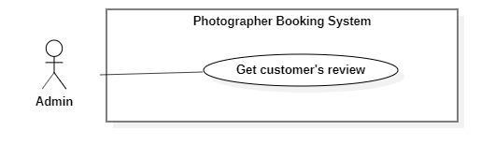

***Figure 35 - <Admin> Get customer's review***

|  |  |  |  |
| --- | --- | --- | --- |
| UC ID and Name: | **PBS-UC-27 Get customer’s review** | | |
| Created By: | Truong Ngoc My | Date Created: | 08/10/2020 |
| Primary Actor: | Admin | Secondary Actors: |  |
| Trigger: | The admin taps the “Trang cá nhân” page of the photographer. | | |
| Description: | The admin can view customer’s review. | | |
| Preconditions: | - User must be an Admin.  - User has logged into the website. | | |
| Post-conditions: | Success: the admin views the customer’s review. | | |
| Normal Flow: | |  |  |  | | --- | --- | --- | | Step | Actor Action | System Response | | 1 | The admin taps “Trang cá nhân” page. | - The system shows the “Trang cá nhân” page of the photographer. [Exception 1] | | | |
| Alternative Flows: | N/A | | |
| Exceptions: | N/A | | |
| Priority: | Medium | | |
| Frequency of Use: | Sometimes | | |
| Business Rules: | BR-23, BR-24 | | |
| Other Information: | N/A | | |
| Assumptions: |  | | |

***Table 28 - <Admin> Get customer's review use case specification***

1. ***<Admin> Add shooting category***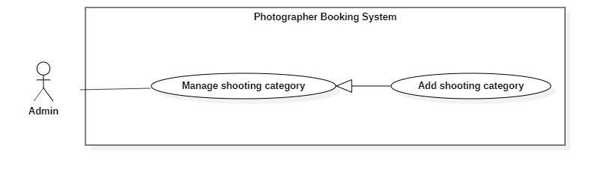

***Figure 36 - <Admin> Add shooting category***

|  |  |  |  |
| --- | --- | --- | --- |
| UC ID and Name: | **PBS-UC-28 Add shooting category** | | |
| Created By: | Truong Ngoc My | Date Created: | 08/10/2020 |
| Primary Actor: | Admin | Secondary Actors: |  |
| Trigger: | The admin taps “Thêm thể loại” button. | | |
| Description: | The admin can add a shooting category. | | |
| Preconditions: | - User must be an Admin.  - User has logged into the website. | | |
| Post-conditions: | Success: The admin can add shooting successfully and update “Trang chủ” of customer’s application. | | |
| Normal Flow: | |  |  |  | | --- | --- | --- | | Step | Actor Action | System Response | | 1 | The admin taps “Thêm thể loại” button. | The system shown “Thêm thể loại chụp ảnh” page. The admin input following:  - “Tên thể loại”: input text, required.  - “Xác nhận” : button.  - “Hủy”: button | | 2 | The photographer taps the “Xác nhận” button. | - The system validates inputted data  [Exception 1, 2]  - The system shows notifications to the photographer. [Exception 3]. | | | |
| Alternative Flows: | N/A | | |
| Exceptions: | |  |  |  | | --- | --- | --- | | No | Actor Action | System Response | | 1 | “Tên thể loại” is empty | System shows an error message : “Thông tin này bắt buộc” | | 2 | “Tên thể loại” is duplicate | System shows an error message : “Thể loại này đã tồn tại” | | 3 | The photographer taps the “Xác nhận” button. | System shows an error message:  “Thêm thể loại thành công”. | | | |
| Priority: | Medium | | |
| Frequency of Use: | Sometimes | | |
| Business Rules: | BR-12 | | |
| Other Information: | N/A | | |
| Assumptions: |  | | |

***Table 29 - <Admin> Add shooting category use case specification***

1. ***<Admin> Edit shooting category***

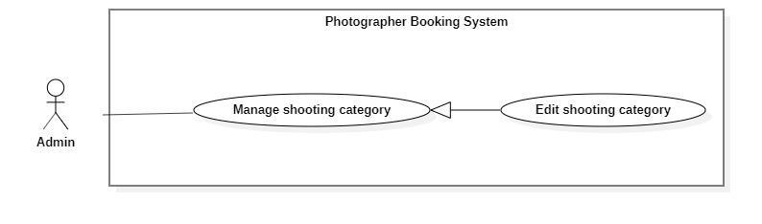

***Figure 37 - <Admin> Edit shooting category***

|  |  |  |  |
| --- | --- | --- | --- |
| UC ID and Name: | **PBS-UC-29 Edit shooting category** | | |
| Created By: | Truong Ngoc My | Date Created: | 08/10/2020 |
| Primary Actor: | Admin | Secondary Actors: |  |
| Trigger: | The admin tabs “Chỉnh sửa” button on the “Thể loại” detail screen. | | |
| Description: | The admin can edit the shooting category. | | |
| Preconditions: | - User must be an Admin.  - User has logged into the website.  - The category available. | | |
| Post-conditions: | Success: The admin can edit shooting successfully and update “Trang chủ” of customer’s application. | | |
| Normal Flow: | |  |  |  | | --- | --- | --- | | **Step** | **Actor Action** | **System Response** | | 1 | The admin taps “Thể loại” to the view detail . | The system showed a list of category pages.  - “Tên thể loại”: text  - “Xóa”: button  - “Chỉnh sửa” : button. | | 2 | The photographer taps the “Cập nhật” button. | The system shown “Thể loại” detail screen. The admin input following:  - “Tên thể loại”: input text, required.  - “Xác nhận” : button. | | 3 | The photographer taps the “Xác nhận” button. | - The system validates inputted data  [Exception 1, 2]  - The system shows notifications to the photographer. [Exception 3]. | | | |
| Alternative Flows: | N/A | | |
| Exceptions: | |  |  |  | | --- | --- | --- | | **No** | **Actor Action** | **System Response** | | 1 | “Tên thể loại” is empty | System shows an error message : “Thông tin này bắt buộc” | | 2 | “Tên thể loại” is duplicate | System shows an error message : “Thể loại này đã tồn tại” | | 3 | The photographer taps the “Xác nhận” button. | System shows an error message:  “Thay đổi thể loại thành công”. | | | |
| Priority: | Medium | | |
| Frequency of Use: | Sometimes | | |
| Business Rules: | BR-13 | | |
| Other Information: | N/A | | |
| Assumptions: |  | | |

***Table 30 - <Admin> Edit shooting category use case specification***

1. ***<Admin> Remove shooting category***

***Figure 38 - <Admin> Remove shooting category***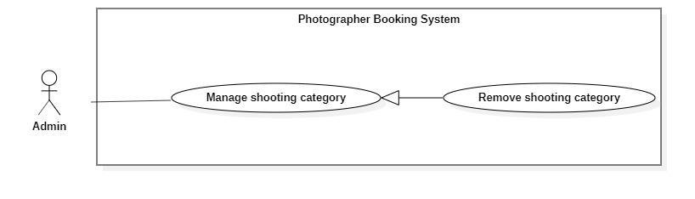

|  |  |  |  |
| --- | --- | --- | --- |
| UC ID and Name: | **PBS-UC-29 Edit shooting category** | | |
| Created By: | Truong Ngoc My | Date Created: | 08/10/2020 |
| Primary Actor: | Admin | Secondary Actors: |  |
| Trigger: | The admin tabs “Xóa” button on the “Danh sách thể loại” screen. | | |
| Description: | The admin can remove the shooting category. | | |
| Preconditions: | - User must be an Admin.  - User has logged into the website.  - The category available. | | |
| Post-conditions: | Success: The admin can remove shooting successfully and update “Trang chủ” of customer’s application. | | |
| Normal Flow: | |  |  |  | | --- | --- | --- | | Step | Actor Action | System Response | | 1 | The admin taps “Thể loại” to the view detail . | The system showed a list of category pages.  - “Tên thể loại”: text  - “Xóa”: button  - “Chỉnh sửa” : button. | | 2 | The admin taps “Xóa” button | The system shows notifications to the photographer. [Exception 1] | | 3 | The photographer taps the “Xác nhận” button. | - The system shows notifications to the photographer. [Exception 2]. | | | |
| Alternative Flows: | N/A | | |
| Exceptions: | |  |  |  | | --- | --- | --- | | No | Actor Action | System Response | | 1 | The admin taps remove the category icon. | System shows an error message : “Bạn có muốn xóa thể loại này ra khỏi thư mục?” | | 2 | The photographer taps the “Xác nhận” button. | System shows an error message:  “Xóa thể loại thành công”. | | | |
| Priority: | Medium | | |
| Frequency of Use: | Sometimes | | |
| Business Rules: | BR-14 | | |
| Other Information: | N/A | | |
| Assumptions: |  | | |

**Table 31 - <Admin> Remove shooting category use case specification**

## 3. Functional Requirements

### 3.1 System Functional Overview

#### a. Screen Flow

1. **Customer’s screen flow**

***Figure 39 - Customer's Screen Flow***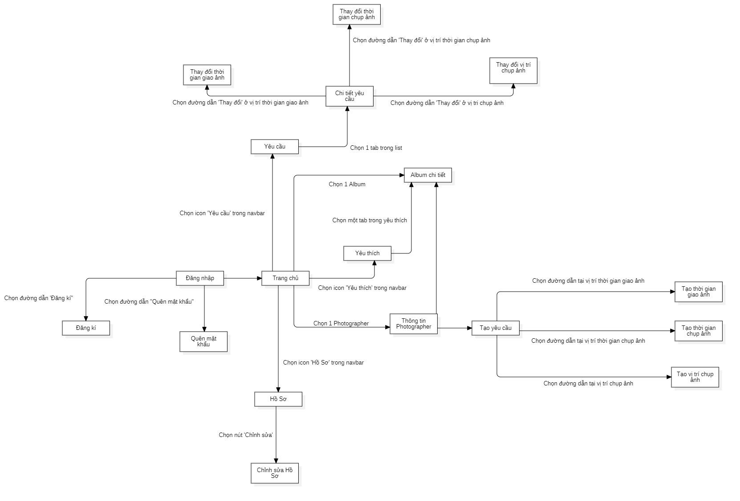

1. **Photographer’s screen flow**

#### b. Screen Details

**1. Customer’s screen details**

|  |  |  |  |
| --- | --- | --- | --- |
| # | Feature | Screen | Description |
| 1 | Register | Đăng ký | Register screen included: avatar, tên đăng nhập, họ và tên, mật khẩu, nhập lại mật khẩu, số điện thoại, địa chỉ. |
| 2 | Login | Đăng nhập | Login screen included: Tên đăng nhập, mật khẩu. |
| 3 | Login | Quên mật khẩu | Forgot password screen included: Mật khẩu cũ, mật khẩu mới, xác nhận mật khẩu. |
| 4 | View application | Trang chủ | Main screen included: Search icon, category, photographer được đánh giá cao, Album được đánh giá cao… |
| 5 | View profile | Hồ sơ | Profile screen included: Họ và tên, tên đăng nhập, số điện thoại, địa chỉ. |
| 6 | Update profile | Chỉnh sửa hồ sơ | Edit profile screen included: Họ và tên, số điện thoại, địa chỉ. |
| 7 | View request | Yêu cầu | Request screen included: Trạng thái, tên photographer, thời gian, gói chụp ảnh, địa điểm. |
| 8 | View request | Chi tiết yêu cầu | Detail request screen included: Trạng thái, thời gian, và địa điểm, thông tin photographer, Thông tin gói dịch vụ. |
| 9 | Update request | Thay đổi thời gian chụp ảnh | Change booking time screen included: calendar |
| 10 | Update request | Thay đổi thời gian nhận ảnh | Change delivery time screen included: calendar |
| 11 | Update request | Thay đổi vị trí chụp ảnh | Change booking address screen included: map |
| 12 | View album | Album chi tiết | Detail album screen include: yêu thích, photographer, description |
| 13 | View album | Yêu thích | “Yêu thích” screen include: number of heart |
| 14 | View profile photographer | Thông tin photographer | Profile photographer screen included: tên, đánh giá. Mô tả, album, các gói dịch vụ, lịch làm việc. |
| 15 | Book photographer | Tạo yêu cầu | Create request screen include: photographer, thời gian chụp, thời gian nhận, địa điểm , gói dịch vụ, giá. |
| 16 | Book photographer | Tạo thời gian chụp ảnh | Create booking time screen included: calendar |
| 17 | Book photographer | Tạo thời gian nhận ảnh | Create delivery time screen included: calendar |
| 18 | Book photographer | Tạo vị trí chụp ảnh | Create booking address screen included: map |

#### c. Screen Authorization

|  |  |  |  |  |  |
| --- | --- | --- | --- | --- | --- |
| **Screen** | **Guest** | **Customer** | **Photographer** | **Admin** | **Authenticated User** |
| Register | X |  |  |  |  |
| Photographer’s login |  |  | X |  | X |
| Customer’s login |  | X |  |  |  |
| Forgot password |  | X | X | X |  |
| Photographer’s home screen |  |  | X |  |  |
| Customer’s home screen |  | X |  |  |  |
| Search photographer |  | X |  |  |  |
| Category |  |  |  | X |  |
| Photographer được đánh giá cao |  | X |  |  |  |
| Album được đánh giá cao |  | X |  |  |  |
| Photographer’s detail |  | X |  | X |  |
| Các gói dịch vụ |  | X |  |  |  |
| Book photographer |  | X |  |  |  |
| Calendar |  | X |  |  |  |
| View review |  | X | X | X |  |
| Booking detail |  | X |  |  |  |
| Choose start time |  | X |  |  |  |
| Choose delivery time |  | X |  |  |  |
| Choose Address |  | X |  |  |  |
| Activity screen |  | X |  |  |  |
| Chờ xác nhận |  |  | X |  |  |
| Sắp diễn ra |  |  | X |  |  |
| Hậu kỳ |  |  | X |  |  |
| Done |  |  | X |  |  |
| Review |  | X |  |  |  |
| Đã hủy |  |  | X |  |  |
| Setting screen |  | X | X |  |  |
| Profile |  | X | X |  |  |
| Edit profile |  | X | X |  |  |
| Change password |  | X | X |  |  |
| Log out |  |  |  |  | X |
| Service |  |  | X |  |  |
| Service detail |  |  | X |  |  |
| Edit service |  |  | X |  |  |
| Remove Service |  |  | X |  |  |
| Add service |  |  | X |  |  |

In which:

* Guest: là người chưa thể dùng các dịch vụ của hệ thống.
* Customer: là người có thể tạo yêu cầu cho photographer
* Photographer: là người có thể chuyển đổi trạng thái của các yêu cầu
* Admin: là người quản lý chung cho hệ thống
* Authenticated user: là người dùng có thể thay đổi hồ sơ.

#### d. Non-Screen Functions

*[Provide the descriptions for the non-screen system functions, i.e batch/cron job, service, API, etc.]*

|  |  |  |  |
| --- | --- | --- | --- |
| **#** | **Feature** | **System Function** | **Description** |
| 1 | <<Feature Name>> | <<Function Name1>> | <<Function Name1 Description>> |
| 2 | … |  |  |

#### e. Entity Relationship Diagram

**Entities List**

|  |  |  |
| --- | --- | --- |
| **#** | **Entity** | **Description** |
| 1 | Customer | Customer is a collection of entities: customerId, username, password, fullname, phone, address avatar. |
| 2 | Admins | Admin is a collection of entities: id, username, password, fullname, phone, address,avatar. |
| 3 | Booking | Booking is a collection of entities: customerId, photographerId, bookingDate, bookingTime, status, dateCreate, location. |
| 4 | Category | Category is a collection of entities: id, name, description. |
| 5 | Album | Album is a collection of entities: id, name, images |
| 6 | Photographer | Photographer is a collection of entities: photographerId, username, password, fullname, phone, address, avatar, description, rating. |
| 7 | Service | Service is a collection of entities: serviceId, name, price, description. |
| 8 | Review | Review is a collection of entities: customerId, photographerId, rating, comment. |

### 3.2 <<Feature Name 1>>

#### a. <<Function Name 1>>

*[A function can be a screen or a non-screen function (listed in the part 5.1 above). In this part, you need to provide the details on the related function, focus on mentioning below information*

* *Function trigger: how this function is triggered (navigation path, a timing frequency, etc.*
* *Function description: actors/roles, purpose, interface, data processing, etc.*
* *Screen layout: mockup prototype of the screen, sample below is for Manage Products screen*

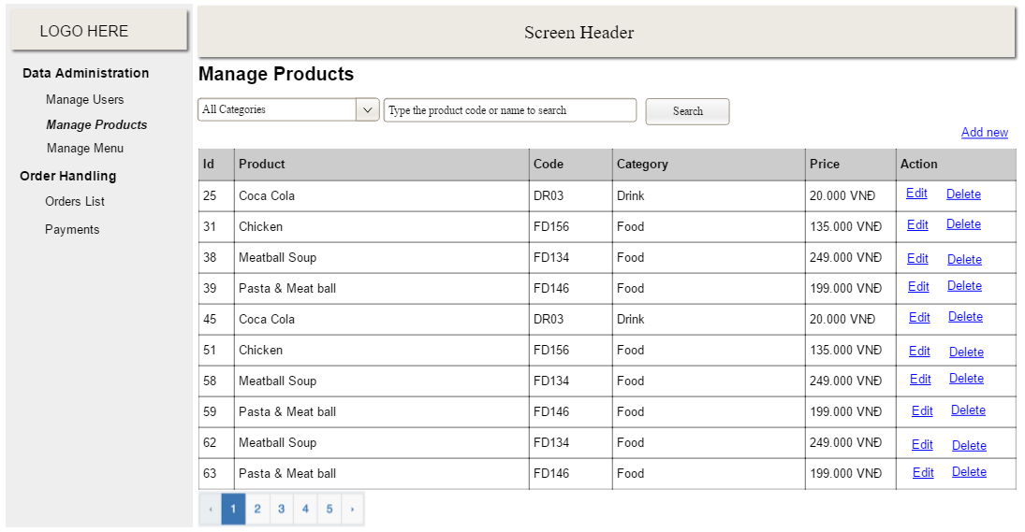

* *Function Details: provide explanation for the data, validation, functionalities (for both normal cases and abnormal cases), etc. of the function so that the reader can image how it work.*

*]*

#### b. <<Function Name 2>>

…

### 3.3 <<Feature Name 2>>

…

## 4. Non-Functional Requirements

### 4.1 External Interfaces

#### a. User Interfaces

For web application:

UI-1: GUI phải đơn giản, dễ sử dụng.

UI-2: Ngôn ngữ trong web phải là tiếng Việt.

UI-3: Trang web phải đáp ứng sử dụng trên: laptop, tablet, mobile.

For mobile application:

UI-1: Giao diện dễ nhìn, dễ sử dụng.

UI-2: Ngôn ngữ phải dùng tiếng Việt.

UI-3: GUI phải chia độ phân giải ở nhiều màn hình.

UI-4: Các chức năng được sắp xếp và rõ ràng.

#### b. Software Interfaces

|  |  |  |
| --- | --- | --- |
| **Software** | **Name / Version** | **Description** |
| Operation System | Windows 7, Windows 10 | Operating system and platform for development |
| Environment | Java EE 11.0.8 | Specification for developing the web application |
| Modeling tool | StarUML, draw.io, Lucidchart | Use for design diagram |
| IDE | Visual Studio Code, Android Studio, IntelliJ | Programming tools |
| DBMS | MySQL | Use to create & manage the database for system |
| Source control | Git, GitHub | Use for source control |
| Web browser | Chrome 69 or above | Testing browser |

#### c. Hardware Interfaces

For server:

|  |  |  |
| --- | --- | --- |
| **Hardware** | **Minimum Requirement** | **Recommended** |
| Internet Connection | Cable, Wi-Fi (8 Mbps) | Cable, Wi-Fi (50 Mbps or more) |
| Operation System | Windows 7, Windows 10 | Windows 10 |
| Computer Processor | Intel® Xeon ® 1.4GHz | Intel® Xeon ® Quad Core (12M Cache, 2.50 GHz) |
| Computer memory | 4GB RAM | 32 GB RAM or more |
| Storage space | 1GB | 8GB or more |

For PC:

|  |  |  |
| --- | --- | --- |
| **PC** | **Minimum Requirements** | **Recommended** |
| Internet Connection | Cable, Wi-Fi (4 Mbps) | Cable, Wi-Fi (8 Mbps) |
| Operating System | Windows 7 | Windows 7 or more. |
| Computer Processor | Intel® Core i3 1.4GHz | Intel® Core i5 2.50GHz |
| Computer Memory | 1GB RAM | 2GB RAM or more |
| Web Browser | Chromes (v42 or higher) | Chrome latest stable version |

#### d. Communications Interfaces

CI-1: PBS sẽ gửi email đến người dùng để xác nhận khi tài khoản của người dùng đang vi phạm hoặc có hành vi xấu nào xuất hiện.

### 4.2 Quality Attributes

#### a. Usability

* Hệ thống không yêu cầu người dùng phải có hiểu biết trước khi sử dụng các chức năng của hệ thống.
* Bố cục và điều hướng màn hình rõ ràng dễ sử dụng.
* Khách hàng có thể sử dụng PSB dễ dàng với ngôn ngữ bằng tiếng Việt dù chưa từng sử dụng ứng dụng này. Tìm kiếm thợ chụp ảnh và đặt lịch trong vòng 5 phút.
* Photographer có thể sử dụng PBS dễ dàng với ngôn ngữ tiếng Việt dù chưa từng sử dụng. Việc xem và nhận các yêu cầu từ khách hàng trong vòng 5 phút. Ngoài ra sử dụng các chức năng khác cũng vô cùng nhành chóng với các mô tả dễ hiểu và thao tác dễ dàng.

#### b. Reliability

* Tình khả dụng của hệ thống là 80%, có thể sử dụng trong vòng 60 phút, nếu không thao tác trong vòng 5 phút sẽ tự động log out.
* Hệ thống sẽ hoạt động trung bình 1000 giờ trong 1 năm, và số lần xảy ra lỗi trung bình là 8 giờ nên Mean Time Between Failures (MTBF) sẽ là 125 giờ.
* Mean Time To Repair (MTTR) sẽ là 24 giờ.

#### c. Performance

tất cả các yêu cầu sẽ được xử lý trong vòng 10 giây trên kết nối internet trên 25Mbps

#### d. Dependability

##### d1. Security

* Tất cả mật khẩu của khách hàng sẽ được mã hóa trước khi lưu trữ vào cơ sở dữ liệu.
* Các tài khoản sẽ được xác thực bằng email.
* Tên đăng nhập không được phép trùng lặp nhau.
* Email và số điện thoại của thợ chụp ảnh sẽ được bảo mật.

##### d2. Safety

* Giá của các gói dịch vụ mà photographer đã đăng khi khách hàng chọn thì không được thay đổi. Nếu có thu phụ phí thì phải thương lượng với khách hàng.
* Đến ngày giao ảnh mà photographer không trả ảnh thì yêu cầu sẽ tự hủy.

#### e. Supportability

#### f. Design Constraints

* Ngôn ngữ phần mềm là tiếng Việt
* Quy trình phần mềm được sử dụng là scrum.

#### g. Support Documents

Hệ thống không sử dụng các tài liệu tham khảo nào để hỗ trợ viết document.

#### h. Purchased Components

Để hỗ trợ hệ thống chúng tôi đã sử dụng các công cụ khác và phải trả phí cho các ứng dụng như:

* Google Map API
* AWS S3

## 5. Other Requirements

### Messages List

|  |  |  |  |  |
| --- | --- | --- | --- | --- |
| # | Message code | Message Type | Context | Content |
| 1 | MSG01 | In line | There is not any search result | Không có kết quả. |
| 2 | MSG02 | In red, under the text box | Input-required fields are empty | Thông tin này là bắt buộc. |
| 3 | MSG03 | Toast message | Updating asset(s) information successfully | Cập nhật thành công. |
| 4 | MSG04 | Toast message | Adding new asset successfully | Thêm * thành công. |
| 5 | MSG05 | Toast message | Confirming email of asset hand-over is sent successfully | A confirmation email has been sent to {email_address}. |
| 6 | MSG06 | Toast message | Resetting asset information successfully | Thay đổi * thành công |
| 7 | MSG07 | Toast message | Deleting asset information successfully | Xóa * thành công. |
| 8 | MSG08 | In red, under the text box | Input value length > max length | Bạn vui lòng nhập đủ{max_length} ký tự. |
| 9 | MSG09 | In line | Username or password is not correct when clicking sign-in | Thông tin đăng nhập không chính xác. |
| 10 | MSG10 | In line | Password and Confirm password is not matched. | Mật khẩu nhập lại không khớp. |
| 11 | MSG11 | Toast message | Register successfully | Đăng ký thành công |
| 12 | MSG12 | In red, under the text box | Email is invalid | Email mail này không hợp lệ. Vui lòng nhập email khác |
| 13 | MSG13 | In red, under the text box | Username is exist | Tên đăng nhập của bạn đã có người sử dụng. Vui lòng nhập tên khác |
| 14 | MSG14 | Toast message | The customer book photographer successfully. | Gửi yêu cầu thành công. |
| 15 | MSG15 | In red, under the text box | The customer does not choose a calendar and address. | Bạn chưa chọn thông tin. |
| 16 | MSG16 | Notifications | The system sends notifications to the customer when photographers accept requests. | Yêu cầu của bạn đã được xác nhận |
| 17 | MSG17 | Notifications | The system sends notification to the customer when a photographer declines a request. | Yêu cầu của bạn đã bị từ chối. |
| 18 | MSG18 | In red, under the text box | Current password is invalid | Mật khẩu nhập lại chưa chính xác |
| 19 | MSG19 | Toast message | The system shows notifications to the admin when blocking users. | Bạn có muốn khóa người dùng này? |
| 20 | MSG20 | Toast message | The admin block user successfully. | Người dùng đã được khóa thành công. |
| 21 | MSG21 | Toast message | The system sends notifications to the user when the account has been blocked. | Tài khoản của bạn đã bị vi phạm. Vui lòng liên hệ với quản trị viên |
| 22 | MSG22 | Toast message | The system shows notifications to the admin when unblocking the user. | Bạn có muốn mở khóa người dùng này? |
| 23 | MSG23 | Toast message | The system sends notifications to the user when the account has unblocked. | Người dùng đã được mở khóa thành công |
| 24 | MSG24 | In red, under the text box | Information is duplicated | * đã tồn tại. |

***Table 1 - Message list***